
3

FAO The Court
C/o Accident Exchange Ltd
Unit 605 Fort Dunlop
Fort Dunlop
Birmingham
B24 9FD

Dear Sirs
RE: Road traffic Accident:
In accordance with your instructions received on 15/02/2024. The report is based on the information provided along with the images taken by the vehicle owner.
Vehicle Advisory Report

Make |  | Registration | EU57 AHC
Model | Octavia | Status | Total loss
Roadworthy | No | Engineers Value | £3,400.00
Temporary Repairs Viable: | In this instance, a suitable temporary repair may be to secure the bumper. Expected cost £60.00.
Engineer Comments: | Please note the vehicle is unroadworthy due to the broken/insecure bumper.

Declaration
The contents of this report are to be used for advice only and not as part of final settlement. The vehicle valuation is based on information taken from Glass’s Guide or open market research and based on average mileage where applicable. Repair costs have not been calculated in full and therefore the repairable / total loss status are based on our professional opinion using the information provided. In some instances once a full accident damage report is compiled opinions may be subject to change. The roadworthiness status within this report has been based on the images provided and is to provide our independent opinion to the Third Party Insures on the validity of hire, we cannot vouchsafe for any latent defects associated with the vehicle and it is assumed the vehicle is in otherwise good running order.
We trust this meets your requirements but should you have any further queries, please do not hesitate to contact us on desk@CollisionEngineers.co.uk.

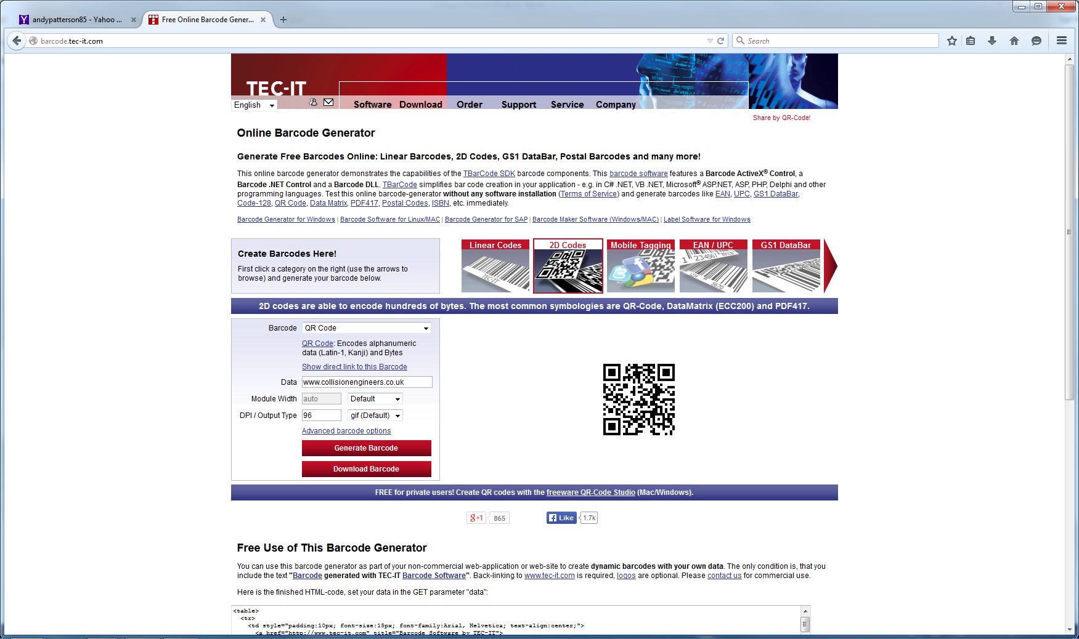
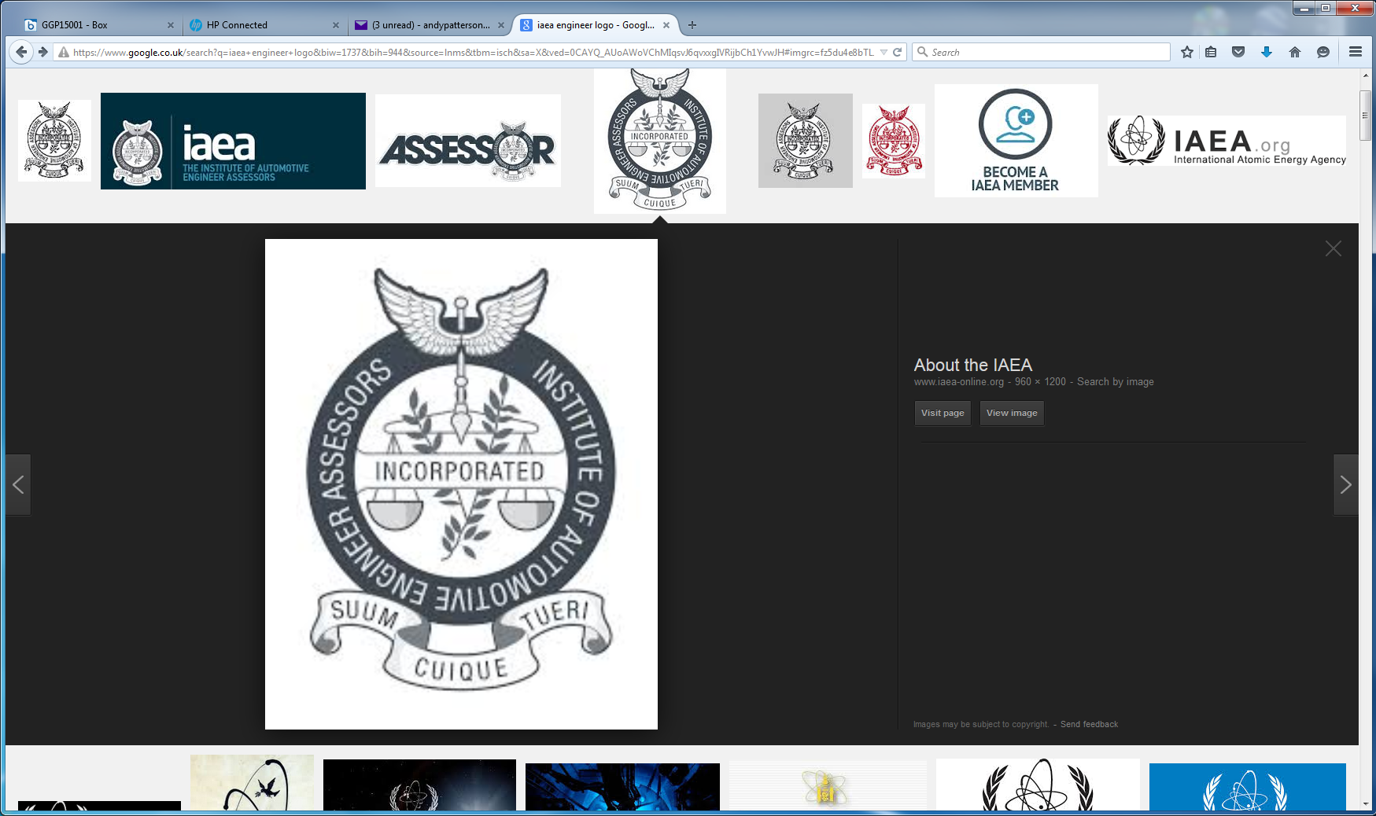
,

Engineers Department

